**Conjoint Analysis**

**Survey Design**

* New cold tea beverage design

**Attributes and Levels**

|  |  |
| --- | --- |
| Attributes | Levels |
| Flavor | Green vs. Black |
| Sweetness | Unsweetened vs. Sweetened |
| Caffeine | Caffeinated vs. Decaffeinated |
| Container | Glass Bottle vs. Can |

**A screenshot of the survey and the number of participants that completed the survey.**

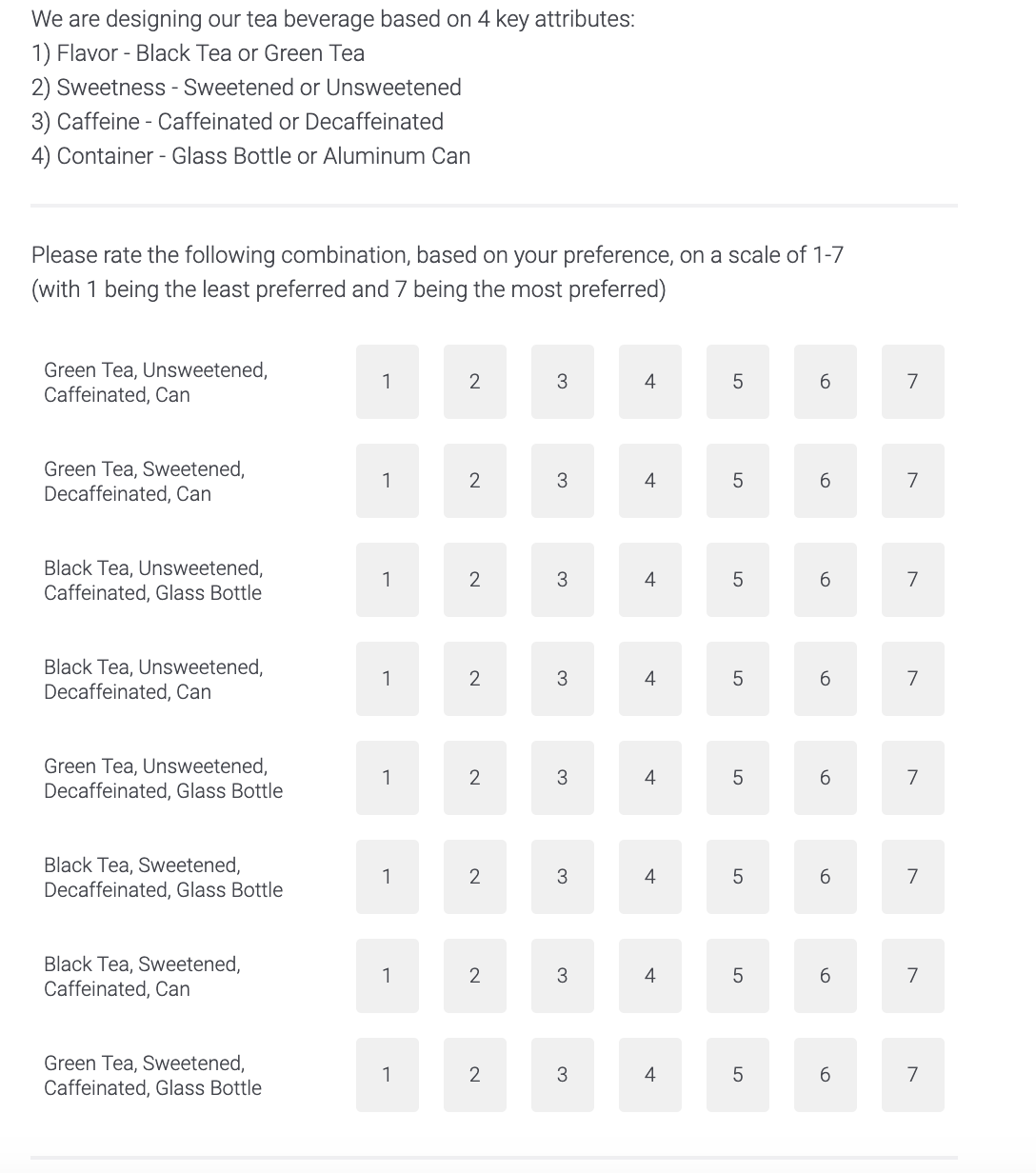



**Average Part-Worth**

|  |  |  |  |
| --- | --- | --- | --- |
|  | | | Ideal Profile |
| Intercept |  | 4.06481 |  |
| Flavor | Black Tea | -0.5 | Green Tea |
| Green Tea | 0.000 |
| Sweetness | Sweetened | 0.46296 | Sweetened |
| Unsweetened | 0.000 |
| Caffeine | Decaffeinated | -0.14815 | Caffeinated |
| Caffeinated | 0.000 |
| Container | Can | -0.62963 | Glass Bottle |
| Glass Bottle | 0.000 |

**Part-Worth Ranges and Attribute Importance**

|  |  |  |
| --- | --- | --- |
| Attribute | Range | Importance |
| Flavor | 0.5 | 0.28723 |
| Sweetness | 0.46296 | 0.26596 |
| Caffeine | 0.14815 | 0.08511 |
| Container | 0.62963 | 0.36170 |

The ideal product would be sweetened, caffeinated green tea in glass container.

**Visualization of the individual part-worth**

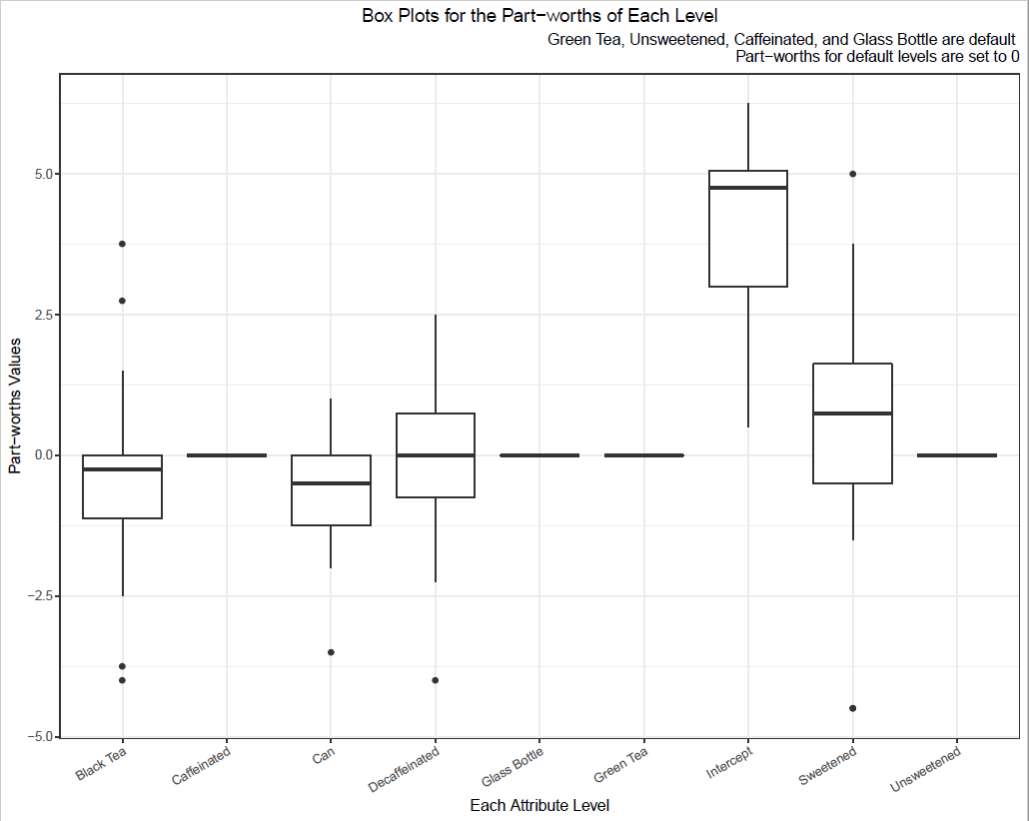

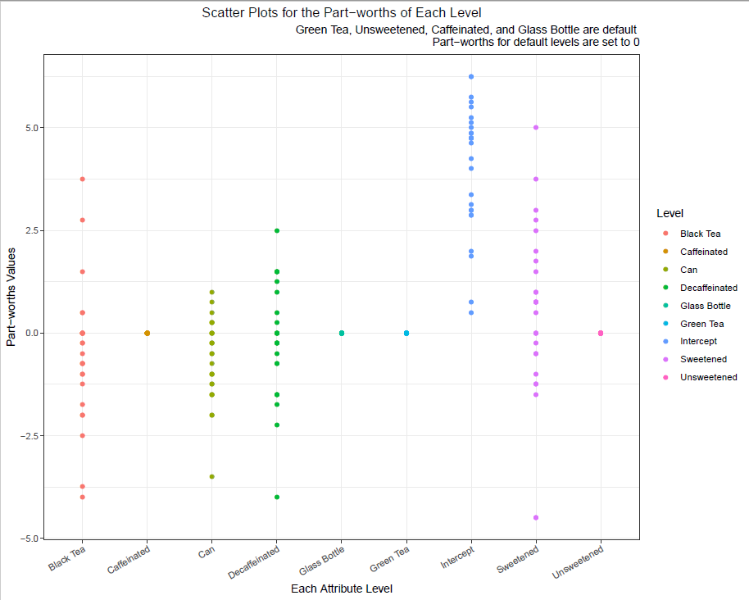

Both figures show that the means of the part-worth values for “flavor” and “container” are both negative, indicating that our respondents generally prefer Green Tea and Glass Bottle. In addition, the mean of the part-worth value for “caffeine” is approximately 0, which means that in general, respondents have no preference between decaffeinated and caffeinated tea. Lastly, the mean of the part-worth value for “sweetness” is significantly greater than 0, implying that participants tend to choose sweetened tea over the unsweetened one.

**Market stimulation to test product**

We ran a market stimulation to find out the forecasted market share for the ideal product.

In the simulations, our competitor product 1 is sweetened, decaffeinated green tea in a can. Competing product 2 is unsweetened, decaffeinated black tea in glass container. Competing product 3 is unsweetened, decaffeinated black tea in can container. For competitor 1, we want to test the effect of caffeine content. For competitor 2, we want to test the improvement effect of container type. For competitor 3, which has the worst product combination, we want to see how much market share would the worst product obtain.

We discovered that the ideal product with maximum average utility is sweetened, caffeinated green tea in glass bottle, so we use that as our own product. The forecasted market share for this ideal product is 51.852%.

Lastly, according to the attribute importance results, we notice that among flavor, sweetness, caffeine, and container type, container type has the greatest importance and the least liked level is the can. So, we redefined our product to sweetened, caffeinated green tea in can container. With same the competitors from the previous simulation, we noticed that the forecasted market share of our modified product would be 20.370%. This significant change in market share was a result of changing our most important attribute, container type, to the least preferred level, which leads to loss of about 30% of our market share. Therefore, we concluded that when purchasing, consumers care about the container type the most and are likely to choose our competitors’ products if we changed the container type to can.